Deploying static website
sudo apt-get update -y

sudo apt-get install apache2

sudo systemctl start apache2

sudo systemctl enable apache2

sudo systemctl status apache2

sudo nano /etc/apache2/sites-available/000-default.conf //default page of apache

download the code from html5up-paradigm-shift

cd Downloads/ //just to check download

ls

cd .. // come out of download

sudo cp Downloads/html5up-paradigm-shift.zip . //copy from downloads

sudo mkdir myapp

sudo cp html5up-paradigm-shift.zip myapp/. //copy to myapp

cd myapp/

ls

sudo unzip html5up-paradigm-shift.zip //unzip

cd ..

sudo cp -rf myapp/ /var/www/html/. //copy to varwww/html

cd /var/www/html/

sudo nano /etc/apache2/sites-available/000-default.conf //add myapp
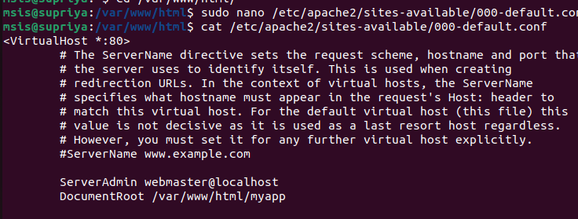
sudo service apache2 restart

sudo ufw allow 80 //if you get any error

open browser and hit ip (172.16.51.49:80)

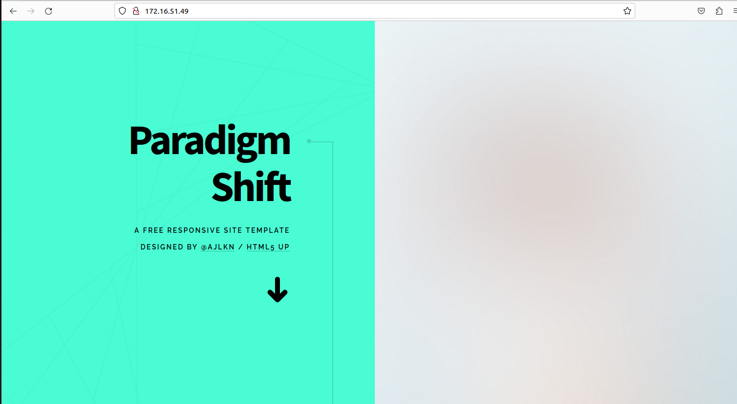
Deploying Dynamic website ecommerce with db

sudo apt-get update -y

sudo apt-get install mysql-server mysql-client php libapache2-mod-php php-mysql

sudo git clone https://github.com/sreepathysois/phpmysql-app.git .

cd phpmysql-app/

ls

cd

sudo mkdir /var/www/html/ecommerce1

ls

cd phpmysql-app/
ls

cd php/

ls

cd online-shopping-system/

sudo cp -rf * /var/www/html/ecommerce1/.

cd /var/www/html/ecommerce1

ls

sudo nano /etc/apache2/sites-available/000-default.conf

sudo systemctl restart apache2

//check browser

sudo systemctl status mysql

sudo mysql -u root -p

show databases;

create user 'aks'@'localhost' identified with mysql_native_password by 'Aks@123'; //create a new user with password

grant all privileges on ecommerce1 .* to 'aks'@'localhost';

use ecommerce1;

exit

cd database/

sudo mysql -u aks -p

use ecommerce1;

source onlineshop.sql;

exit;

cd ..

sudo nano db.php

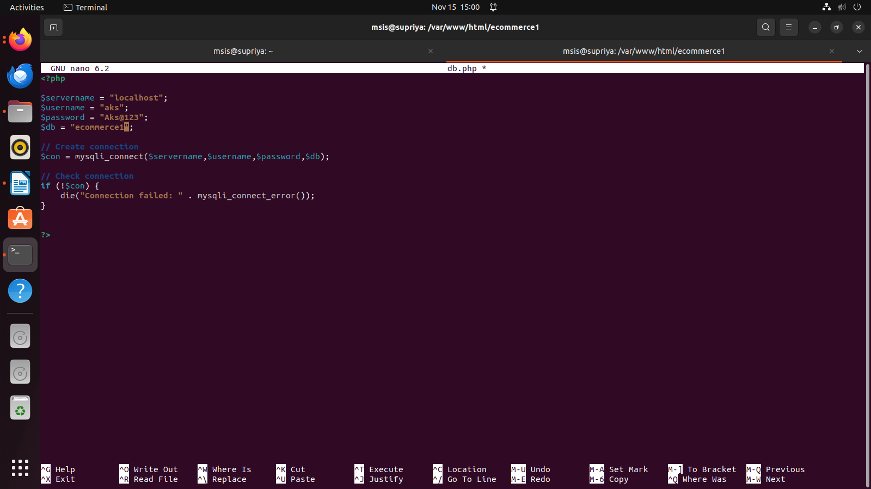

sudo systemctl restart apache2

//check browser

Deploying Dynamic website bookalbum

sudo apt-get install php libapache2-mod-php

cd /var/www/html/

ls

sudo git clone https://github.com/sreepathysois/basic-php-website.git

cd basic-php-website/

ls

sudo nano /etc/apache2/sites-available/000-default.conf

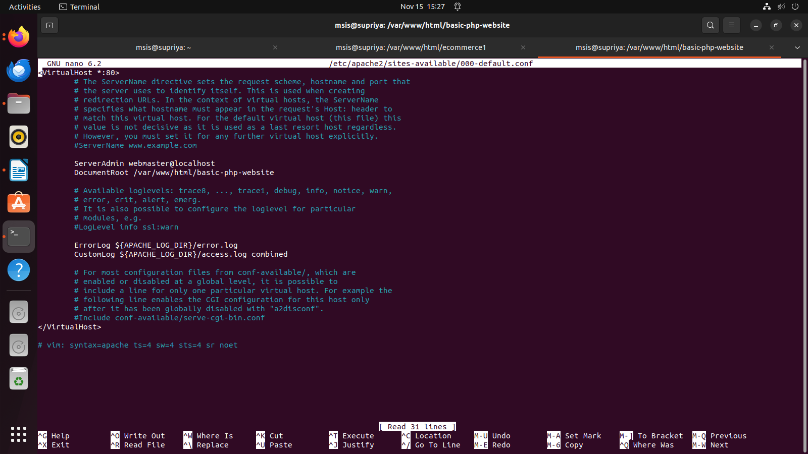

sudo systemctl restart apache2

//check browser

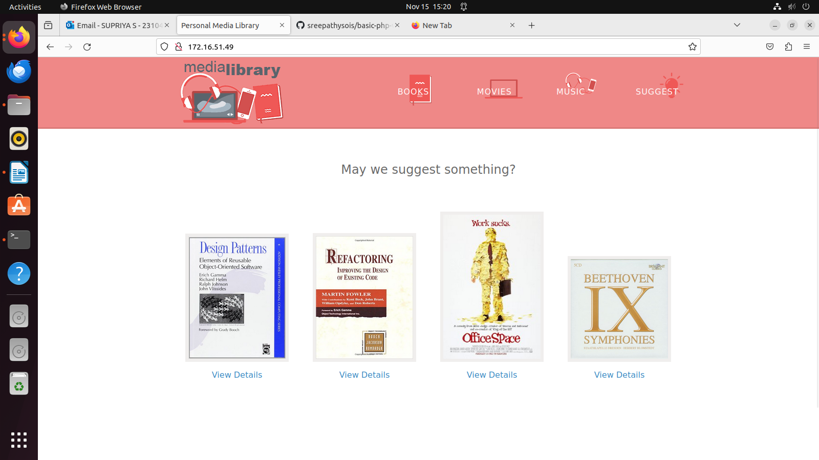
Deploying Static Website using S3

